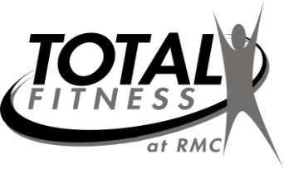
7
MAY 2022
Getting Better Every Day!
Aerobics Calendar
Contact fitness staff at 329-7623/7624 or 215-7455
 | Mon. | Tues. | Wed. | Thurs. | Fri.
May 2-6 | 9:15am Functional Movement-RR  12:15pm Total Body-R  5:15pm MashUp-A | 12:15pm Linear Progression-C  5:15pm Strength Circuit-RR | 9:15am Senior Core-A  12:15pm Zumba-C | 5:30am Instructor Choice-R  12:15pm Step-C  2:15pm Flexibility-A | 9:15am Functional Movement-RR
May 9-13 | 9:15am Senior Circuit-RR  12:15pm Instructor Choice-R  5:15pm Lower Cut-C | 12:15pm Step-A  5:15pm Step-KK | 9:15am Zumba-A  12:15pm Total Body-C | 5:30am Instructor Choice-R  12:15pm Zumba-A  2:15pm Flexibility-RR | 9:15am Functional Movement-RR
May 16-20 | 9:15am Functional Movement-RR  12:15pm Total Body-R  5:15pm Stability Ball-KK | 12:15pm Zumba-C  5:15pm Step-KK | 9:15am Arthritis-A  12:15pm Core Camp-RR | 5:30am Instructor Choice-R  12:15pm Step-A  2:15pm Flexibility-A | 9:15am Functional Movement-RR
May 23-27 | 9:15am Senior Circuit -RR  12:15pm RM Organized Walk/Run-C  5:15 Total Body-D | 12:15pm Linear Progression-RR  5:15pm MashUp-D | 9:15am Senior Core-R  12:15pm Strength Circuit-R | 5:30am Instructor Choice-R  12:15pm Zumba-C  2:15pm Flexibility-RR | 9:15am Functional Movement-RR
May 30-31 | CLOSED  HAPPY MEMORIAL DAY! | 12:15pm Step-C
*Class description on back of calendar*
Instructors for land classes: C - Cara Tidwell; A - Amy Jones;
J - Jan Hare; KK - Karen Kison; D - Deon Maxwell; R - Riley Goree; RR-Robert Reams

*All classes subject to change each month*

THANK YOU FOR CHOOSING RUSSELL MEDICAL!

We will not have class if only one person attends. However, you are welcome to utilize access to our 2 gyms available at all times.

