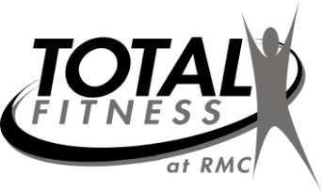
7
NOVEMBER 2022
Getting Better Every Day!
Aerobics Calendar
Contact fitness staff at 329-7623/7624 or 215-7455
 | Mon. | Tues. | Wed. | Thurs. | Fri.
NOV. 1-4 |  | 12:15 Step Interval-C  5:15 Total Body-A | 9:15am Arthritis-A  12:15pm Instructor Choice-RR | 9:15am Senior Core-A  12:15pm Pilates- J | 9:15am Flexibility- RR
NOV. 7-11 | 9:15am Senior Circuit-RR  12:15pm RM Organized Walk/Run-A  5:15pm Total Body-C | 12:15pm Zumba-C  5:15pm Step-A | 9:15am Senior Core-A  12:15pm Linear Progression-A | 9:15am Arthritis-C  12:15pm Total Body-J | 9:15am Functional Movement-RR
NOV. 14-18 | 9:15am Functional Movement-RR  12:15pm Zumba-C  5:15pm Strength Circuit-RR | 12:15pm Total Body with Bands- J  5:15pm Bosu-A | 9:15am Arthritis-A  12:15pm Instructor Choice-RR | 9:15am Senior Core-C  12:15pm Step-C | 9:15am Flexibility-RR
NOV. 21-25 | 9:15am Senior Circuit-RR  12:15pm Total Body-A  5:15pm Step-C | 12:15pm Zumba-C | 9:15am Senior Core-RR  12:15pm Linear Progression-C | HAPPY  THANKSGIVING  CLOSED | HAPPY THANKSGIVING  CLOSED
NOV. 28-30 | 9:15am Functional Movement-RR  12:15pm Zumba-A  5:15pm Athletic Circuits- RR | 12:15 Pilates-J  5:15 Step Interval-A | 9:15am Arthritis-A  12:15pm Instructor Choice-C
*Class description on back of calendar*
Instructors for land classes: C - Cara Tidwell; A - Amy Jones;
J - Jan Hare; KK - Karen Kison; RR-Robert Reams;
G – Gregory Wright;

*All classes subject to change each month*

THANK YOU FOR CHOOSING RUSSELL MEDICAL!

We will not have class if only one person attends. However, you are welcome to utilize access to our 2 gyms available at all times.

