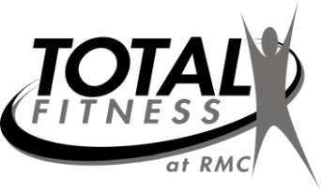
7
DECEMBER 2022
Getting Better Every Day!
Aerobics Calendar
Contact fitness staff at 329-7623/7624 or 215-7455
 | Mon. | Tues. | Wed. | Thurs. | Fri.
DEC. 1-2 |  |  |  | 9:15am Senior Core-A  12:15pm Total Body- RR | 9:15am Flexibility- C
DEC. 5-9 | 9:15am Senior Circuit-RR  12:15pm Zumba-C  5:15pm Step Interval-A | 12:15pm RM walk/run- J  5:15pm Step-KK | 9:15am Senior Core-A  12:15pm Linear Progression-A | 9:15am Arthritis-C  12:15pm Pilates-J | 9:15am Functional Movement-RR
DEC. 12-16 | 9:15am Functional Movement-RR  12:15pm Zumba-A  5:15pm Linear Progression- C | 12:15pm Step-C  5:15pm Strength Circuit-RR | 9:15am Arthritis-A  12:15pm Instructor Choice-RR | 9:15am Senior Core-C  12:15pm Total Body- J | 9:15am Flexibility-RR
DEC. 19-23 | 9:15am Senior Circuit-RR  12:15pm Zumba- A  5:15pm Total Body-RR | 12:15pm Step- C | 9:15am Senior Core-A  12:15pm Linear Progression-C | **No Classes** | MERRY CHRISTMAS!  CLOSED
DEC. 26-30 | MERRY CHRISTMAS!  CLOSED | 12:15 Pilates with Bands-J  5:15 Step Interval-A | 9:15am Arthritis- A  12:15pm Instructor Choice-C | 9:15am Senior Circuit- A  12:15pm Total Body-RR | 9:15am Functional Movement-RR
*Class description on back of calendar*
Instructors for land classes: C - Cara Tidwell; A - Amy Jones;
J - Jan Hare; KK - Karen Kison; RR-Robert Reams;

*All classes subject to change each month*

THANK YOU FOR CHOOSING RUSSELL MEDICAL!

We will not have class if only one person attends. However, you are welcome to utilize access to our 2 gyms available at all times.

